**PRE COLLEGE ENGLISH ONE**

**DIAGNOSTIC TEST (2021)**

**Reading, Grammar, Vocabulary, Writing Diagnostic Test**

**Directions:** Answer all of the following items. Place your answer on the space provided next to each item.

**SECTION A**: **Sentence Structure**

**Directions: Correctly identify the following as:**

**a) Complete sentence b ) fragment c) run-on d) comma splice**

1. The storm that frightened my dog and cat late yesterday afternoon. __run-on______
2. Our family rescued the abandoned puppy from the animal shelter. __Complete sentence______
3. The student became stressed her daily schedule was hectic. __coma splice______
4. Dr. Scott is my dentist, he is a very pleasant person. _complete sentence_______
5. Just as I closed and locked the back door. fragment________

**SECTION B: subject Verb Agreement**

**Directions: In each of the following sentences, choose the verb form which agrees with the subject. Write your choice on the space provided.**

__are___ 6. Both John and his twin (is, are) planning to attend the reunion.

_plans___ 7. My sister, along with my mother, (plans, plan) to tour England.

__were___ 8. Inside the secret panel of the closet (was, were) several old documents.

_has____ 9. Either the newspaper or the magazines (has, have) the information you will need.

_visits____ 10. Everyone in Mrs. Brown's biology classes (visits, visit) the Learning Lab twice each week.

**SECTION C: Pronoun Antecedent**

**Directions: In each of the following sentences, choose the proper form of the pronoun for a correct sentence. Write your choice on the space provided.**

_their____ 11. Everybody must pay (his, their) own entrance fee.

___themselves__ 12. They ventured into the dangerous forest by (their selves, themselves).

__their___ 13. Either the editor or the reporters will correct (her, their) mistake.

___her__ 14. Lisa asked (she, her) if Brad had come by the night before.

__himself___ 15. Jason wanted to do the assignment (his self, himself).

**SECTION D: Parts of Speech**

**Directions: Identify what part of speech the following underlined words are used as in the following sentences. Write the letter on the line provided in front of each item.**

16. __a_____I really enjoy speaking to **friendly** people. a. adjective

1. adverb
2. verb
3. noun

17. __a______ I will go for a drive today when the **weather** changes. a. noun

1. verb
2. adverb
3. pronoun

18. ____A_____Our **English** teacher is very considerate. a.

verb

1. noun
2. adjective
3. adverb

19. ___D_____ **Wow!** That was an exceptional piece of writing. a. verb

1. adverb
2. noun
3. interjection

20. ____a____I am willing to do all I can to ensure a **pass** in this course. a. verb

1. adjective
2. adverb
3. noun

**SECTION E: Context Clues**

**Directions: Determine the meaning of the following bolded words in each sentence using context clues**.

__a___ 21. The reporter insisted that the letter he used was **authentic**. He said that he had shown it to many experts before he used it in his story. a. genuine or real b. carefully written c. full of tasty worms

d. very old

__b___ 22. Friendship is a **priceless** thing. If Chris put a price, or conditions, on her friendship, it is no longer priceless. In fact, it's not real friendship at all.

1. has a missing tag
2. has no value
3. has great value
4. has little value

__c___ 23. No one suspected that Jerry was a spy. On the surface he behaved like any normal citizen.

When his **covert** activity was discovered and announced to the world, we were all shocked. a. friendly

1. doubtful
2. hidden
3. obvious

__a___ 24. We walked down the trail with great **trepidation**. No one who had gone this way had ever been heard from again. a. worry b. enjoyment c. anticipation

d. laughter

__b___ 25. We have rather **lofty** expectations for you, son. You will attend college, become rich and famous and become the next Prime Minister of Belize.

1. shaky
2. high
3. small
4. lowly

**SECTION E: Reading Comprehension**

**Directions: Read the following extract and then answer items 26-30 on the basis of what is stated or implied.**

Marcia says that all of her friends have a cell phone, but Marcia’s mom doesn't want to buy her one. Marcia's mom doesn't want Marcia to play video games either. What is more, the Internet scares her. Marcia's mom says, “If Marcia has a cell phone, how do we know whom she is talking to? Video games are bad for you. The Internet is dangerous and uncontrolled. It’s like having a gun in the house. We should just ban her from using the computer, and I'm not buying her a cell phone until she is eighteen. This is the only way we can be sure that Marcia is safe."

Marcia’s dad disagrees with Marcia's mom. Although he agrees that there are some dangers to it, he likes the Internet, and finds it to be very useful. “The trouble is,” he says, “We just can’t stop Marcia from using the Internet, as this would put her at a disadvantage. What is more, I like video games. I think that, when played in **moderation**, they are fun. Obviously, it is not good to play them without restraint or selfcontrol. Finally, I think Marcia needs a cell phone. We can’t take these things away.”

**__**B**___26)** Which of the following best describes the difference between Marcia's mom and Marcia's dad? A. Mom wants to ban Marcia from using the computer, while dad likes to play video games. B. Mom thinks technology is dangerous, while dad thinks it can be useful.

1. Mom cares little about Marcia's future, while dad is very supportive.
2. Mom is very strict while Dad is open minded.

**_**D**____ 27)** Which of the following best describes the similarity between Marcia's mom and Marcia's dad? A. Mom and dad both like technology.

1. Mom and dad both think video games are bad.
2. Mom and dad both think the internet is dangerous.
3. Mom and dad both care about Marcia's wellbeing.

**_**A_**___ 28)** In paragraph 1, Marcia's mom says, "It's like having a gun in the house." She says this in order to A. support the idea that the Internet is dangerous

1. reject the claim that guns can be safe if used responsibly
2. encourage Marcia's dad to purchase a gun D. explain why the Internet is uncontrolled

**___**C**__ 29)** In paragraph 2, Marcia's dad says, "We just can’t stop Marcia from using the Internet, as this would put her at a disadvantage." What does Marcia's dad mean by this?

1. Marcia needs to learn how to use the internet if she wants to have friends in the future.
2. Marcia should not stop using the internet because this will seriously slow her learning.
3. If a person's ability to use the internet becomes important in the future, Marcia will be at a loss.
4. If Marcia does not learn to use the internet on her own, then she will never learn to recognize its dangers.

**__**D**___ 30)** In paragraph 2, Marcia's dad says, "Finally, I think Marcia needs a cell phone." Given what you know about Marcia’s mom’s concerns, what is the best reason Marcia's dad can provide to convince Marcia's mom that Marcia needs a cell phone?

1. Marcia can use her cell phone to talk to her friends, instead of needing to borrow one of ours.
2. Having a cell phone will teach Marcia how to use new technology.
3. Because all of her friends have one, it would be unfair to disallow Marcia to have a cell phone.
4. If Marcia's is in trouble she can use her cell phone to call for help.

**__**C**___ 31)** Which of the following describes a level of game play that Marcia' dad would disapprove of?

1. On Saturday, Marcia plays video games all evening. The next day, she wakes up early and goes for a walk through the woods near her house. When her friend calls Marcia, they talk about what they are going to wear to school on Monday.
2. Marcia plays video games for an hour or two. Then she eats lunch and meets her friends at the skating rink. That night, Marcia and her friends go to see a movie.
3. Marcia plays video games all morning. When her friends ask her to come play outside, Marcia tells them that she is too busy and continues to play.
4. Marcia plays video games for an hour every day for five days straight. During these days, she does not watch any TV.

**__**B**____ 32)** Marcia's mom can best be described as

1. ridiculous
2. careful
3. cruel
4. rude

**__**D**___ 33)** Marcia's dad can best be described as

1. shameless
2. foolish
3. wild
4. reasonable

__A___ **34)** Which of the following would be the best way for Marcia to change the way her mom thinks about technology?

1. Read her a newspaper article that talks about the importance of technology.
2. Provide her an instruction manual detailing how the latest cell phone functions.
3. Take her to the library and show her the top five most popular internet websites.
4. Spend the weekend playing video games with her.

_B____ **35)** An antonym for the word **moderation** in paragraph 2 is

1. self-control
2. excess
3. reasonably
4. sensibly

**SECTION F: Writing**

Set a timer for 25 minutes. When you’re ready to begin, carefully read the following assignment. Use the space provided to write your paragraph.

★ **Write a paragraph describing your personality.**

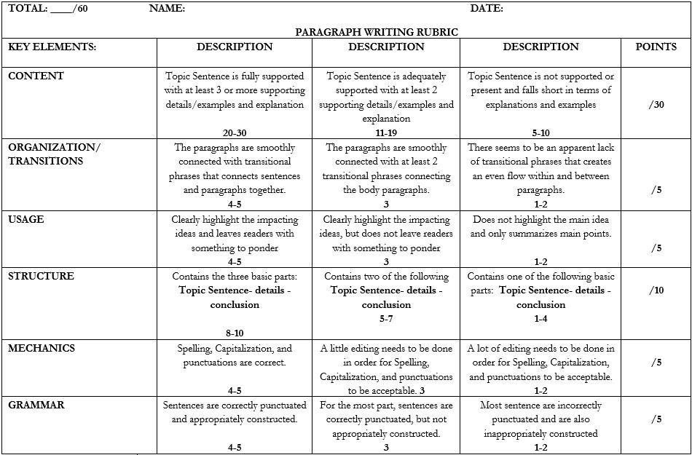

___________________My Personality______________________________

________First_of_all, my name is Abner Pop. I am 21years old I am from down south Toledo from a village name Criquejutevillage .my personality are meny first of all am funny only around family not around friends also I don’t have friend ,I love to be by my self just love to be me. Secondly I love to listen to music 24/7 music is every thing to me,with out music life does not make sense at all. thirdly like most people am a cool person I don’t drink nor smoke also have negative side only when people want to see it ,in life its good to be both. Most of all the best personality of me I never give up in life even if life try to bring me down always smile to life and thanks him to show me the hard way, that’s one thing I learn, I drop many times but always pick my self up, am not that type of smart people am slow learner I fail many times in life but never give up ,one thing I learn to be successful you have to learn n to fail to succeeded if you never fail you will know what is like to fail. success is not measured by the positon one has reached ….but by the effort we put into conquering our objects .